ST10489898

SAMKELO PHETO

PROG ASSIGNMENT 1
SQL QUERY:
GITHUB LINK:
https://github.com/Samkelo-22/RACE-DAY/blob/main/PROG%20ASSIGNMENT%201.docx
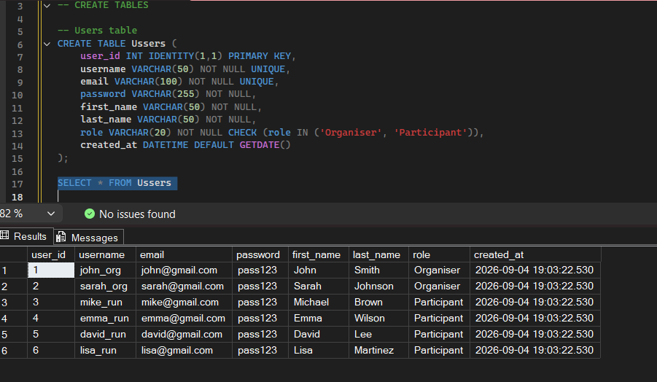
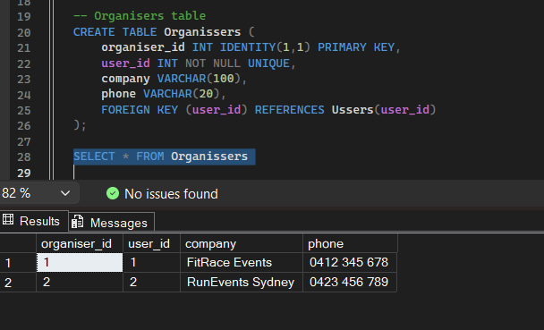
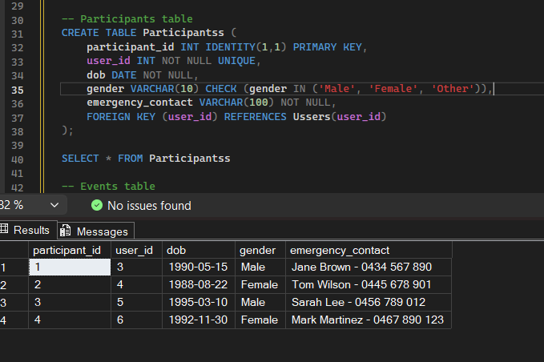
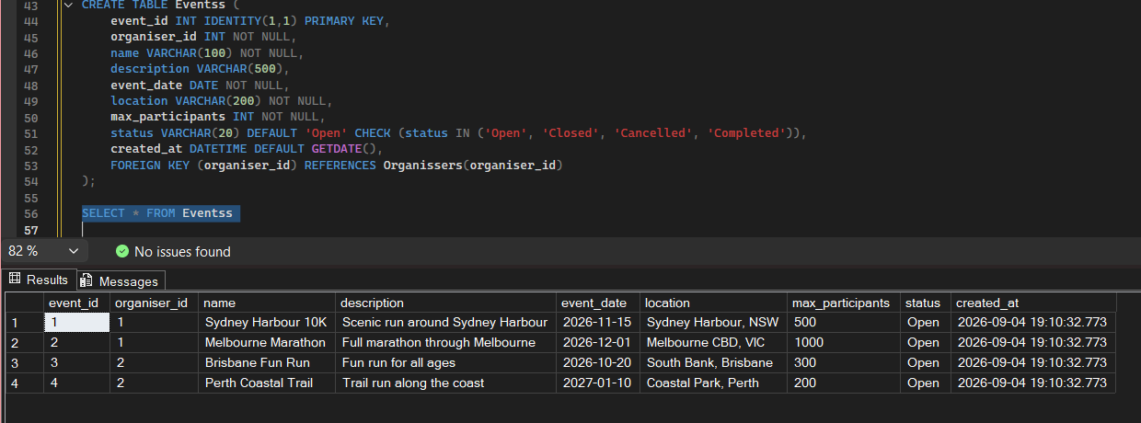
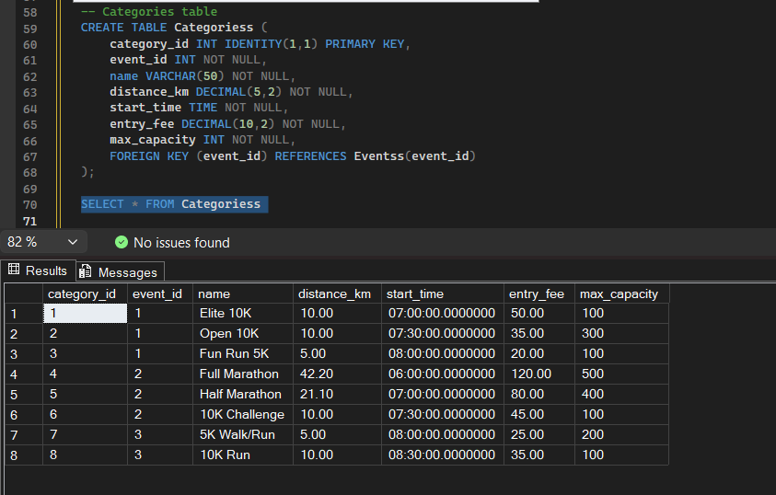
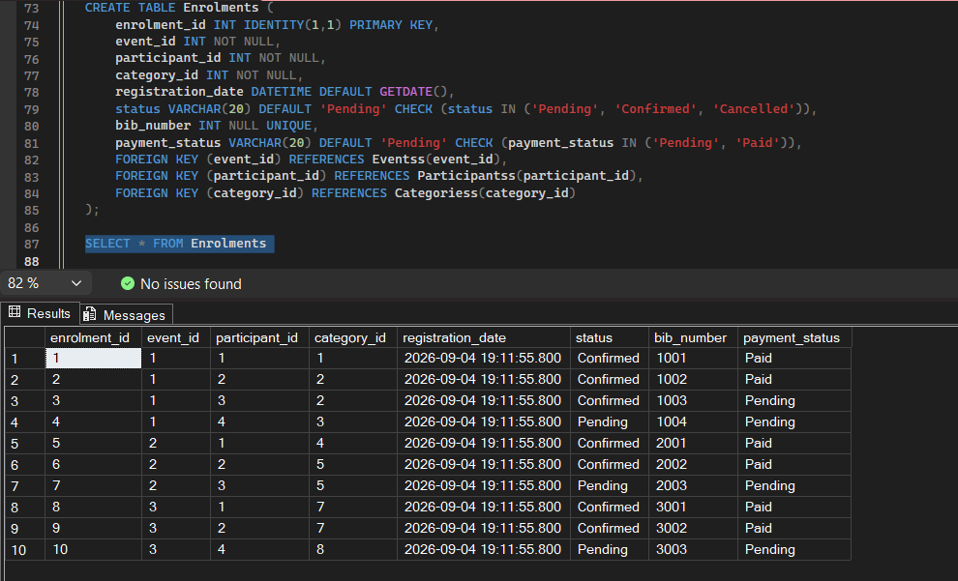
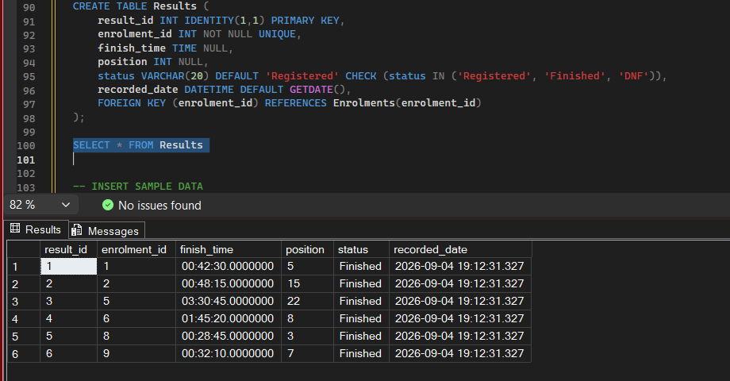
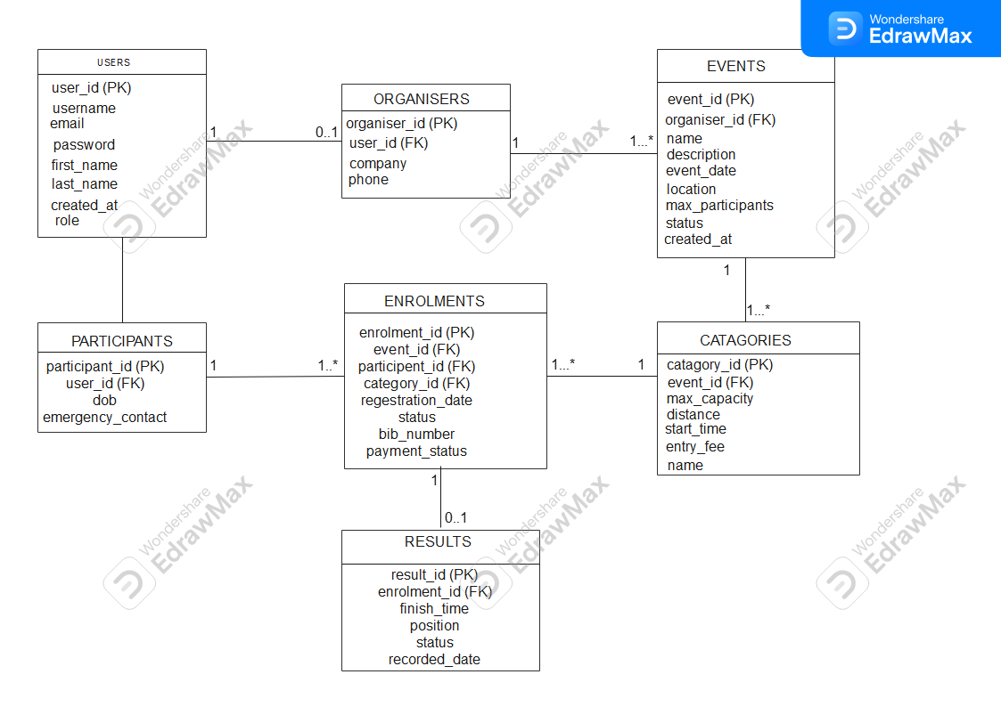
ENDPOINT PLAN:
HTTP METHOD | ROUTE | DESCRIPTION | ROLE | REQUEST BODY | EXPECTED RESPONSE
POST | /api/auth/register | Register | Public | {username, email, password, firstName, lastName, role} | 201 Created / 400 Bad Request
POST | /api/auth/login | Login | Public | {email, password} | 200 OK with token / 401 Unauthorized
GET | /api/users/profile | My Profile | Logged in | None | 200 OK with user data
GET | /api/events | List events | Logged in | None | 200 OK list of events
GET | /api/events/{id} | View count | Loggin in | None | 200 OK event details / 404 Not found
POST | /api/events | Create event | Organiser | {name, description, date, location,maxParticipants} | 201 Created / 400 Error
PUT | /api/events/{id} | Update event | Organiser | {name,description,date,location} | 200 OK updated / 403 Forbidden
DELETE | /api/events/{id} | Delete event | Organiser | None | 204 No Content / 403 Forbidden
POST | /api/events/{id}/enrol | Enrol in event | Participant | {categoryId} | 201 Created / 400 Error
POST | /api/results | Record result | Organiser | {enrolmentID,finishTime,position} | 201 Created / 400 Error

